Problem No:
Problem Statement:

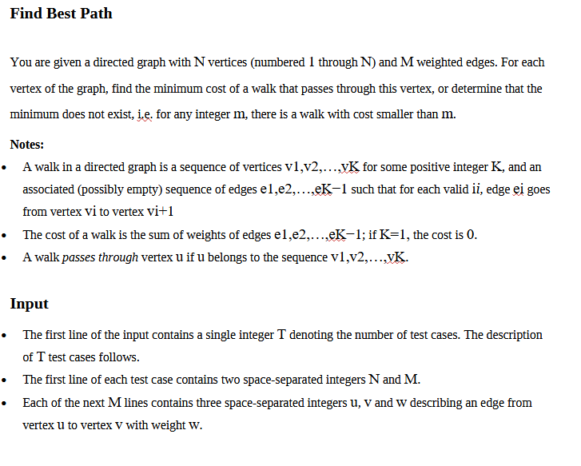

Codes:

#include <bits/stdc++.h>

using namespace std;

using ll = long long;

const ll INF = (ll)1e18;

// Runs Bellman–Ford from a super-source 0 (connected to every 1..n with weight 0).

// edges: list of (u→v, weight w)

// Outputs:

// dist[0..n]: dist[v] = min cost from any start u to v

// neg[0..n]: neg[v] = true if v is reachable from some negative cycle

void bellmanFordSuper(int n,

const vector<tuple<int, int, ll>> &edges,

vector<ll> &dist,

vector<char> &neg)

{

dist.assign(n + 1, INF);

neg.assign(n + 1, 0);

dist[0] = 0;

for (int it = 1; it <= n; it++)

{

bool any = false;

for (auto &e : edges)

{

int u, v;

ll w;

tie(u, v, w) = e;

if (dist[u] < INF && dist[v] > dist[u] + w)

{

dist[v] = dist[u] + w;

any = true;

if (it == n)

neg[v] = 1;

}

}

for (int v = 1; v <= n; v++)

{

if (dist[v] > dist[0])

{

dist[v] = dist[0];

any = true;

if (it == n)

neg[v] = 1;

}

}

if (!any)

break;

}

// DFS To check negative edges

vector<vector<int>> adj(n + 1);

for (auto &e : edges)

{

int u, v;

ll w;

tie(u, v, w) = e;

adj[u].push_back(v);

}

queue<int> q;

vector<char> seen(n + 1, 0);

for (int v = 1; v <= n; v++)

{

if (neg[v])

{

q.push(v);

seen[v] = 1;

}

}

while (!q.empty())

{

int u = q.front();

q.pop();

for (int w : adj[u])

{

if (!seen[w])

{

seen[w] = 1;

neg[w] = 1;

q.push(w);

}

}

}

}

int main()

{

ios::sync_with_stdio(false);

cin.tie(nullptr);

int T;

cin >> T;

while (T--)

{

int n, m;

cin >> n >> m;

vector<tuple<int, int, ll>> edges, redges;

edges.reserve(m);

redges.reserve(m);

for (int i = 0; i < m; i++)

{

int u, v;

ll w;

cin >> u >> v >> w;

edges.emplace_back(u, v, w);

redges.emplace_back(v, u, w);

}

vector<ll> dist_to, dist_from;

vector<char> neg_to, neg_from;

// shortest-to-v

bellmanFordSuper(n, edges, dist_to, neg_to);

// shortest-from-v

bellmanFordSuper(n, redges, dist_from, neg_from);

// combine and print

for (int v = 1; v <= n; v++)

{

if (neg_to[v] || neg_from[v])

{

cout << "INF\n";

}

else

{

cout << (dist_to[v] + dist_from[v]) << "\n";

}

}

}

return 0;

}

Output:

